**Project: E-Commerce Application CI/CD Deployment on EKS**

**Automate the deployment of an e-commerce web application using AWS DevOps services with scalability, security, and observability.**

**Submitted By – Heena**

**1. Introduction**

**1.1. Problem Statement**

Modern e-commerce platforms require high availability, rapid feature delivery, and robust security. Manual deployments are error-prone and slow, making it difficult to scale and maintain reliability. The challenge was to design and implement a fully automated, cloud-native CI/CD pipeline for both frontend and backend applications, leveraging AWS services and Kubernetes (EKS) to ensure seamless, secure, and observable deployments.

**1.2 Scope**

This project delivers a complete CI/CD pipeline for an e-commerce web application, deployed on AWS EKS. The solution automates everything from source code commits to production deployment, including infrastructure provisioning, application build, containerization, and monitoring.

**1.3 Objectives**

* Automate end-to-end deployment for frontend (React.js) and backend (Node.js) apps.
* Use AWS CodePipeline and CodeBuild for CI/CD.
* Containerize applications using Docker and manage images in ECR.
* Deploy to a scalable, secure EKS cluster using CloudFormation.
* Implement robust monitoring and alerting with CloudWatch and SNS.
* Ensure security, scalability, and observability throughout the stack.

**2. Solution Architecture**

This solution implements a modern, cloud-native e-commerce platform on AWS using a microservices approach and fully managed services for scalability, security, and automation.

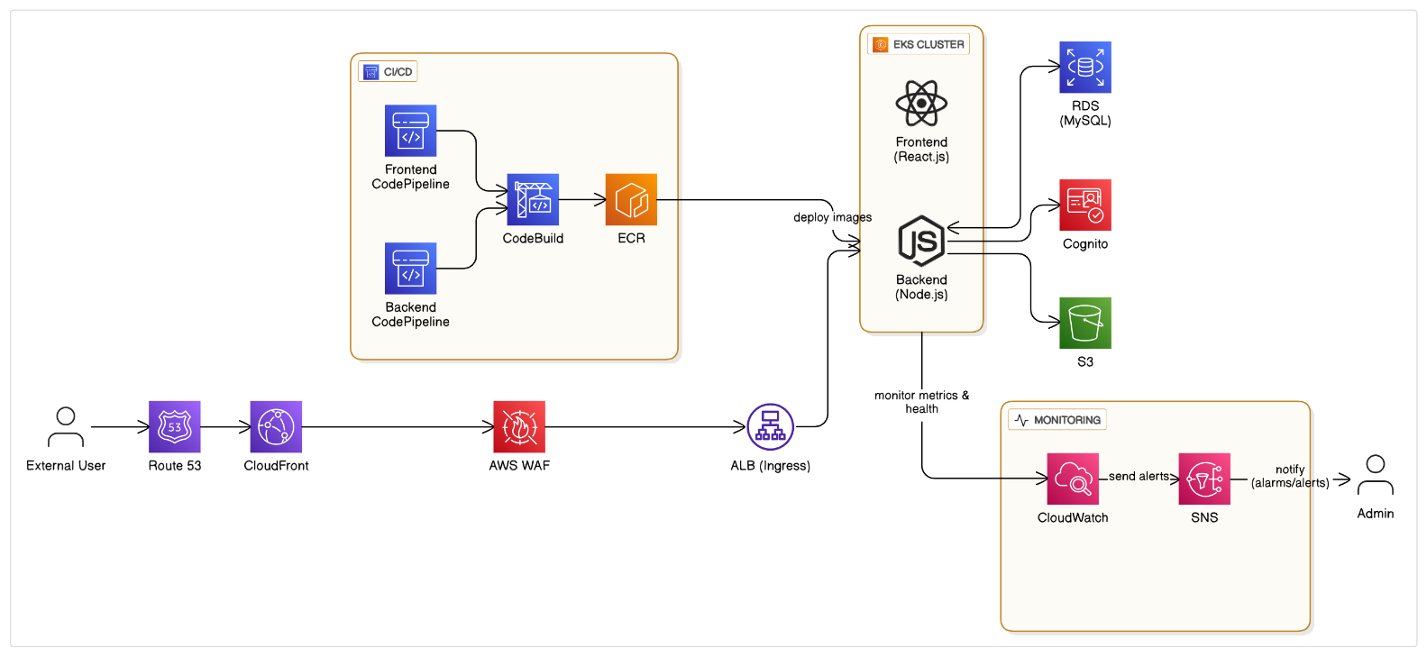

* + 1. Architectural Diagram of E-Commerce WebApp DevOps implementation on AWS.

**Description:** The architecture consists of:

* **Source Control:** GitHub triggers separate CodePipelines for frontend (React.js) and backend (Node.js) on code commits.
* **Build & Containerization:** CodeBuild installs dependencies, builds the apps, and creates Docker images, pushing them to ECR.
* **Infrastructure Provisioning:** CloudFormation templates deploy the EKS cluster, VPC, ALB, RDS, S3 buckets, and Cognito user pool.
* **Deployment:** Kubernetes manifests are applied to EKS, updating deployments and services with the new Docker images from ECR.
* **Traffic Routing:** ALB routes external traffic to EKS pods; S3 serves static assets and images; Cognito handles authentication.
* **Monitoring & Alerts:** CloudWatch collects logs and metrics; SNS sends notifications for pipeline events and application alerts.

**3. AWS Services Utilized**

**3.1 Compute & Orchestration**

* **EKS (Elastic Kubernetes Service):** Hosts and orchestrates the containerized frontend and backend apps.
* **EC2:** Underlying worker nodes for EKS.

**3.2 Networking**

* **VPC, Subnets:** Isolated, secure networking for EKS and supporting services.
* **ALB (Application Load Balancer):** Routes external traffic to EKS pods.
* **CloudFront & WAF:** Provides CDN and web application firewall.

**3.3 Storage & Database**

* **ECR (Elastic Container Registry):** Stores Docker images built by CodeBuild.
* **RDS (PostgreSQL/MySQL):** Managed database for backend services.

**3.4 DevOps & Automation**

* **CodePipeline:** Orchestrates the CI/CD flow for both frontend and backend.
* **CodeBuild:** Runs build and containerization steps for each app.
* **CloudFormation:** Infrastructure as Code for all AWS resources.

**3.5 Security & Identity**

* **IAM:** Manages permissions for all services.
* **Cognito:** Provides secure user authentication and authorization for application users
* **Security Groups:** Firewall rules for EKS, ALB, and RDS.
* **Secrets Manager:** Securely stores, manages, and rotates sensitive information.
* **Certificate Manager (ACM):** Provisions, manages, and automatically renews SSL/TLS certificates for secure HTTPS communication.

**3.6 Monitoring & Alerts**

* **CloudWatch:** Collects logs and metrics from EKS, ALB, and other resources.
* **SNS:** Sends notifications for alarms and pipeline events.

**4. Detailed Implementation**

**4.1 GitHub & CodePipeline Integration**

* Created a GitHub repo: [ecommerce-eks-cicd](https://github.com/HeenaDania/ecommerce-eks-cicd.git)

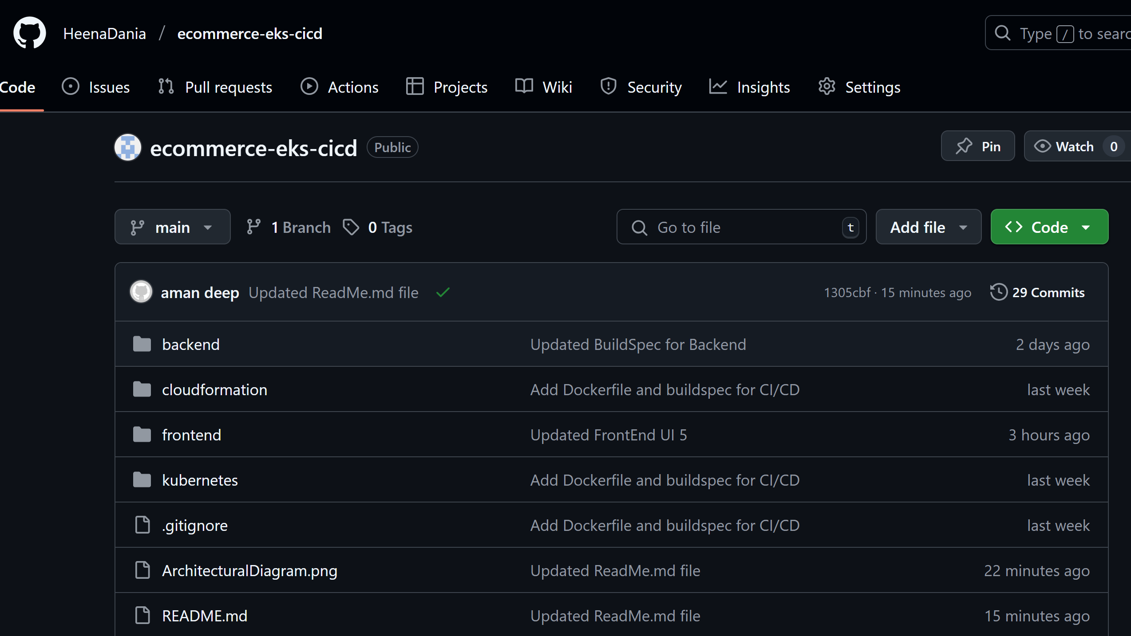

2. GitHub repository of this ecommerce-app.

* Configured webhooks for push events.
* Separate CodePipelines for frontend and backend, each with their own CodeBuild projects.

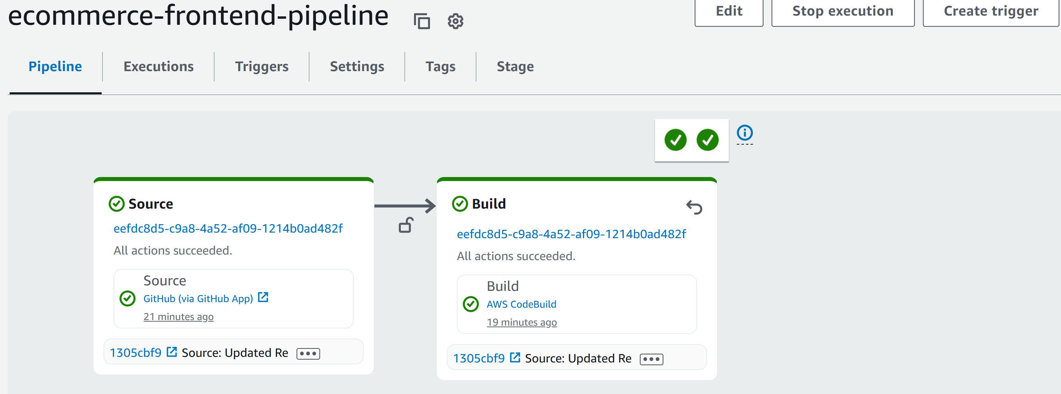

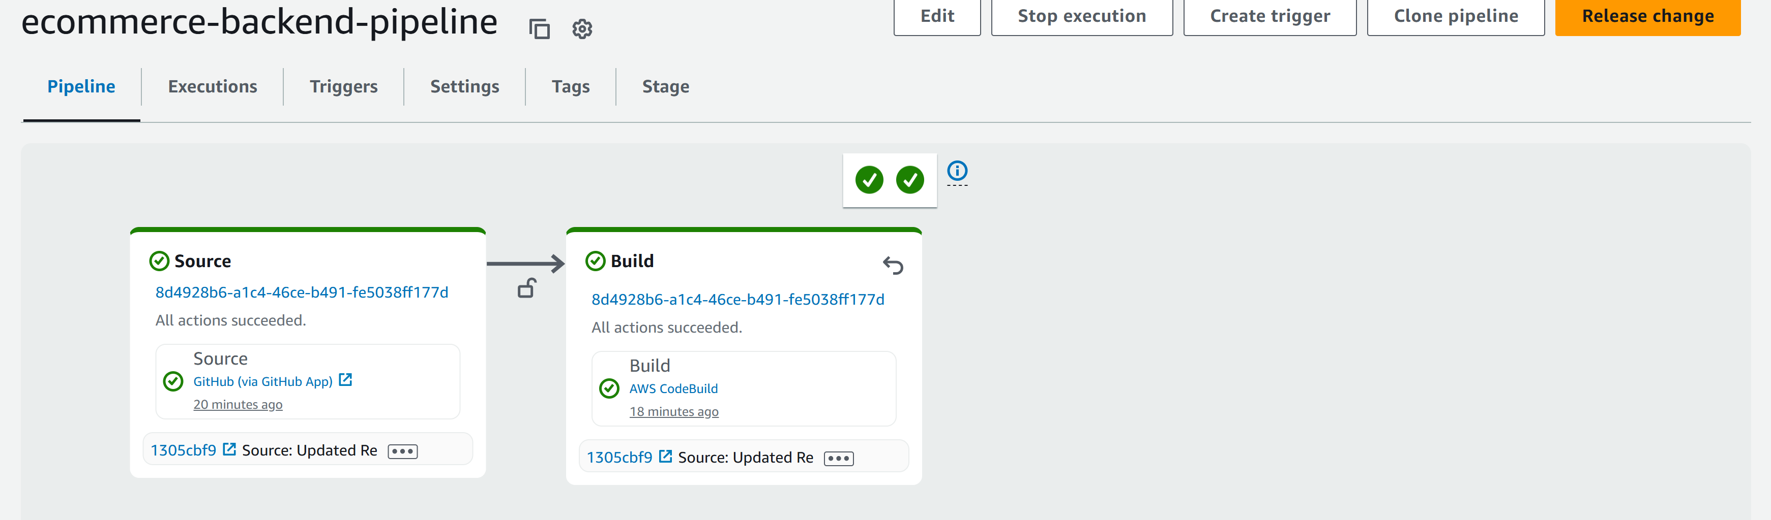

3. Two different CodePipelines for frontend and backend respectively.

**4.2 Handling Build & Deployment Challenges**

* **Node.js ESM, Babel, and Build Configuration:**
  + Configured Babel and Node for modern JS and React.
  + Managed ESM/CJS compatibility across all configs.
  + Ensured all dependencies are listed in package.json and installed via npm install in CI.
  + Kept node_modules/ in .gitignore for best practice and clean builds.
* **Dependency Management:**
  + Resolved multiple build errors related to missing dependencies and ESM/CJS issues by adjusting configurations and ensuring all required packages were present.

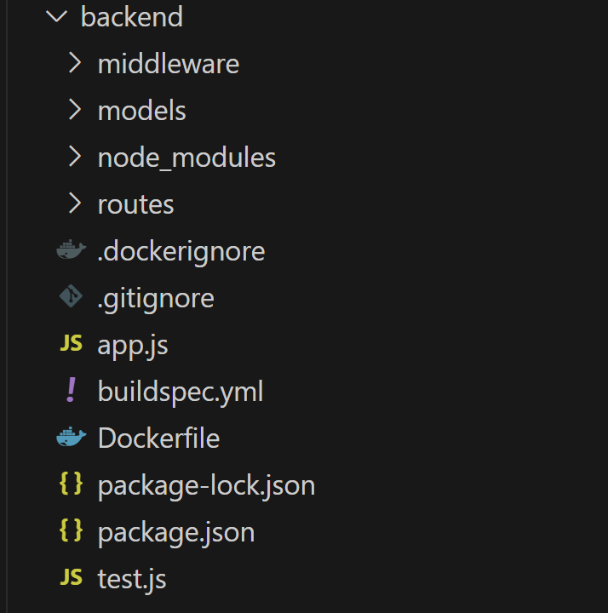

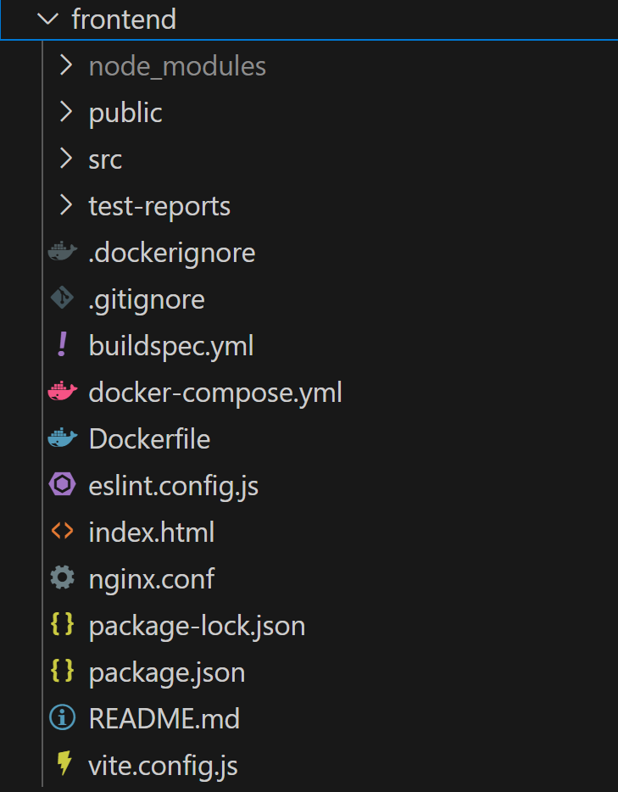

4. Frontend and Backend folder structures containing all the necessary application code and dependencies installed.

**4.3 Containerization & ECR**

* Dockerfiles for both frontend and backend.

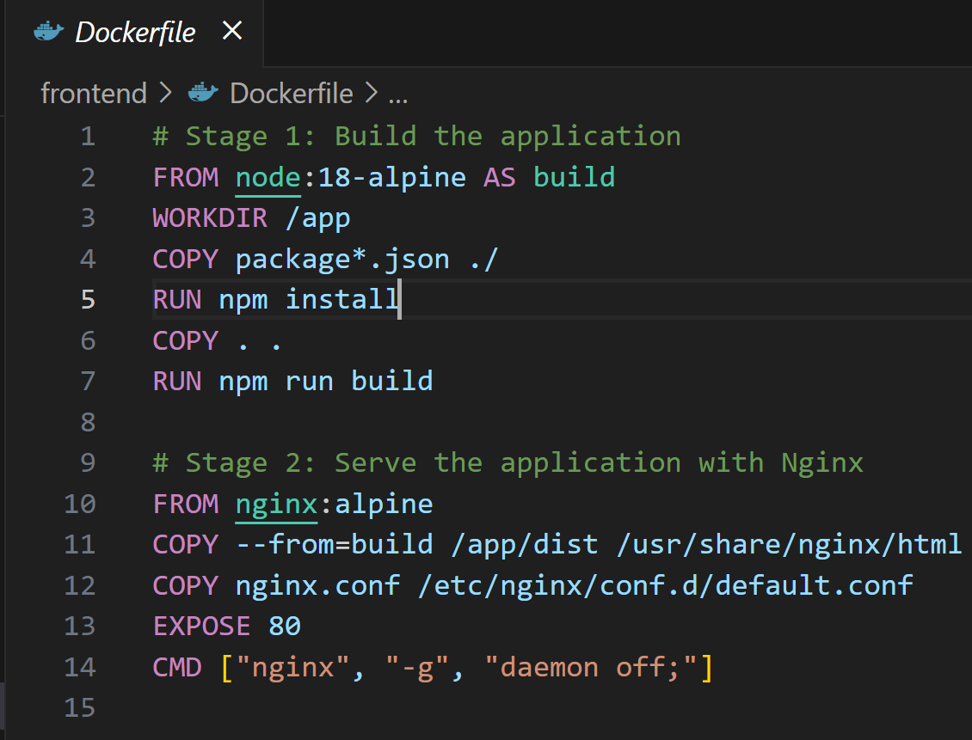

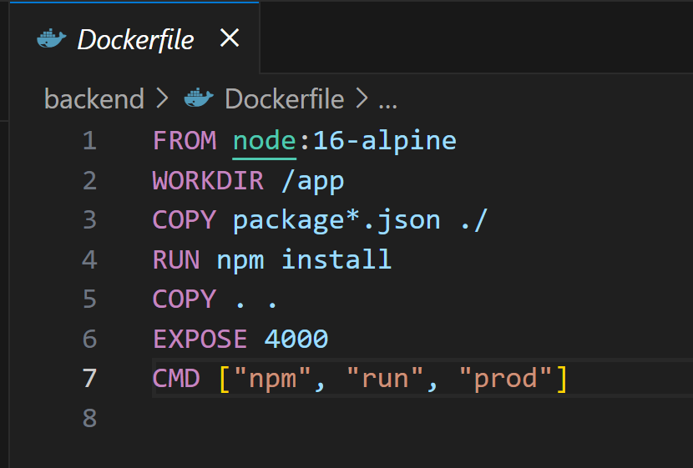

5. Docker files for frontend and backend respectively.

* CodeBuild builds images and pushes to ECR on every successful build.

**

6. Elastic Container Registry storing latest images for both frontend and backend.

**4.4 EKS & CloudFormation**

* CloudFormation templates automate the provisioning of all AWS infrastructure.

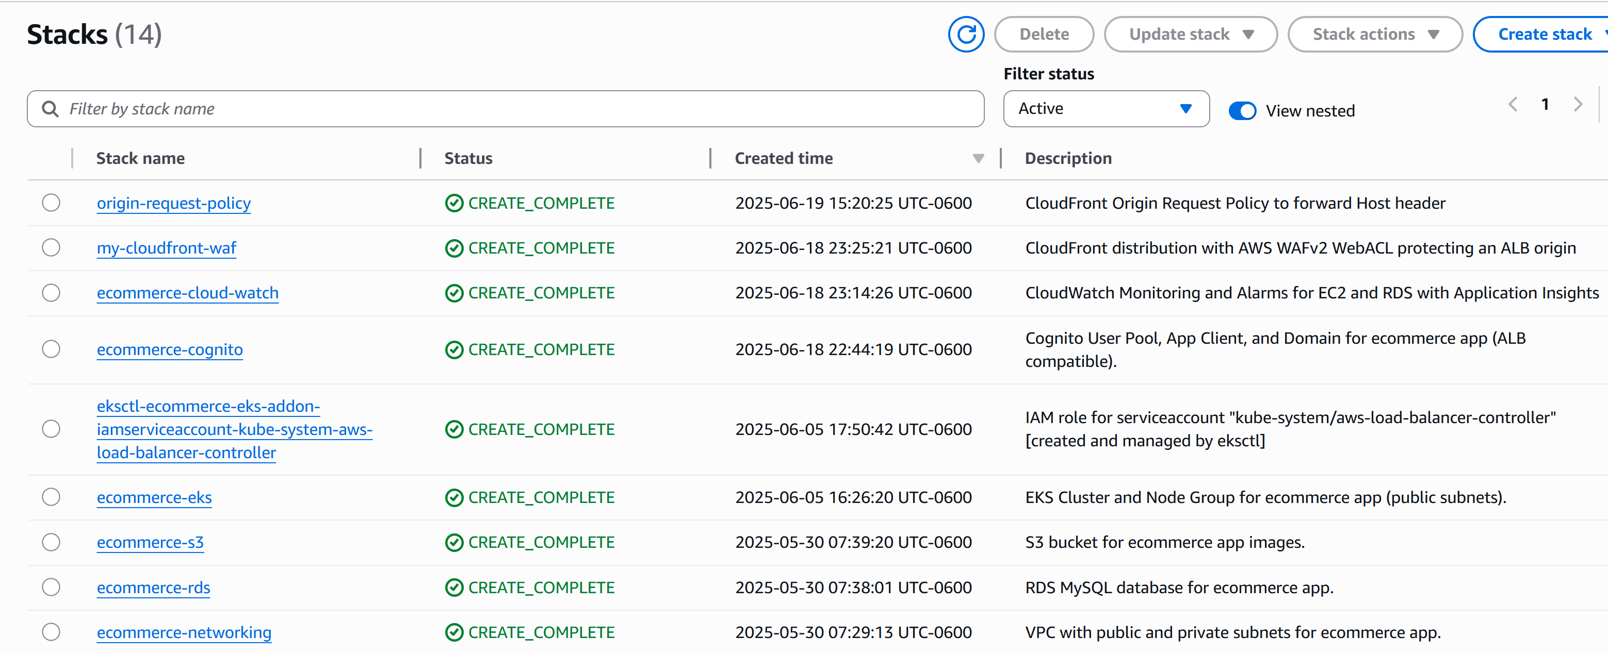

7. CloudFormation Stacks showing infrastructure built as Code.

* EKS cluster created with worker nodes, security groups, and IAM roles.

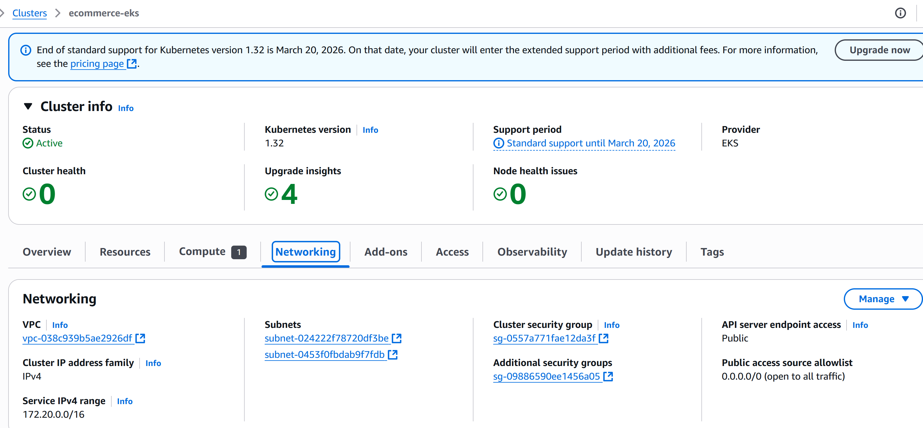

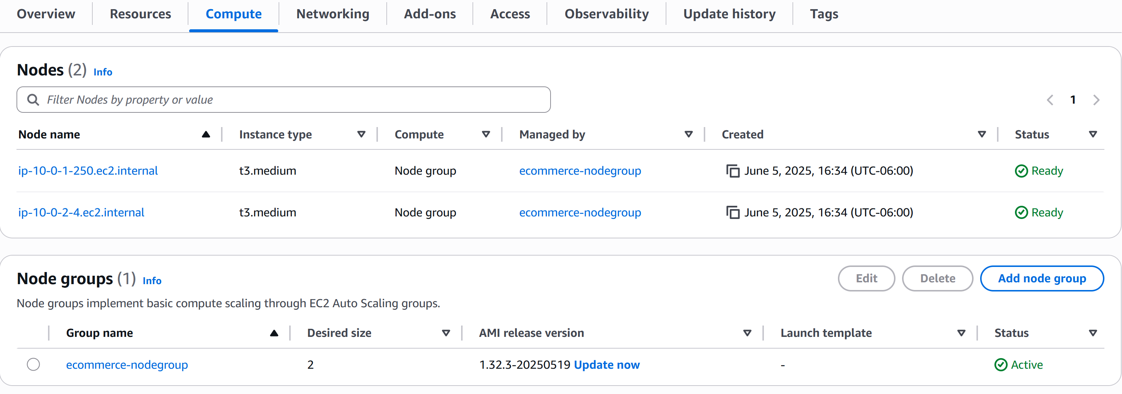

8. Elastic Kubernetes Service showing its working nodes, groups, security and networking information.

* ALB and RDS provisioned and integrated.

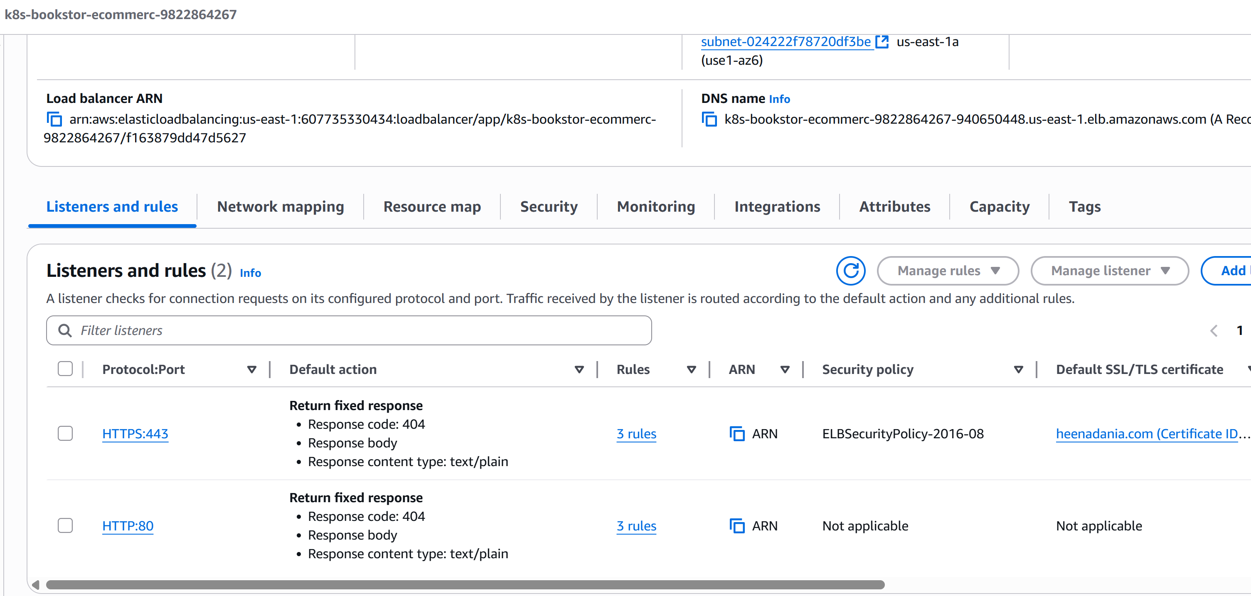

9. Application Load Balancer distributing the traffic among EC2 instances and forwarding request to heenadania.com.

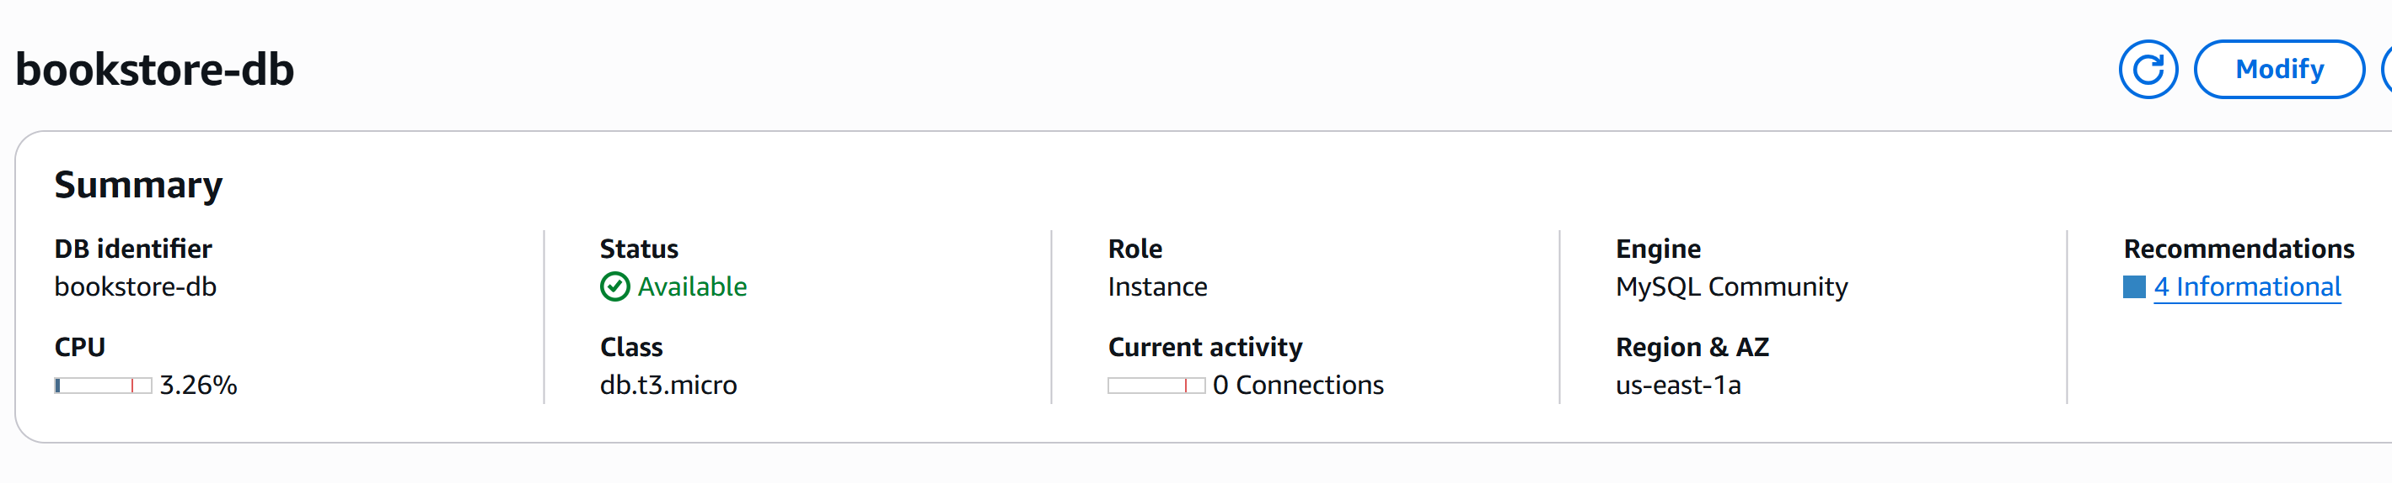

10. RDS created by using CloudFormation to store WebApp details such as Books details from my ecommerce-Bookstore App.

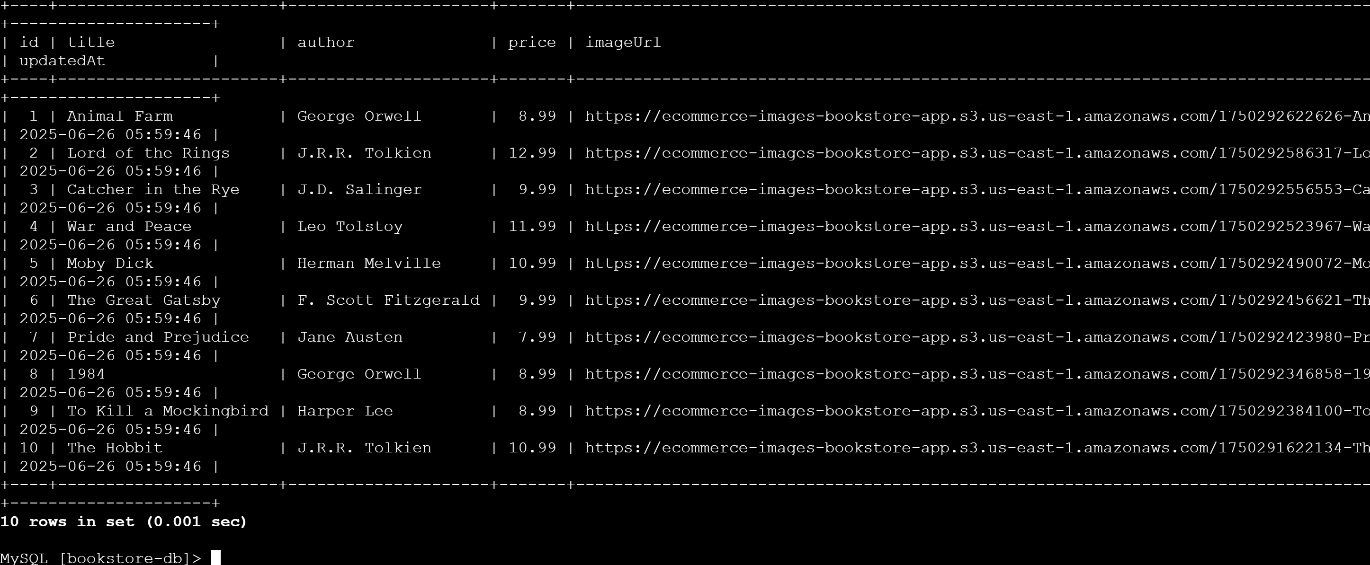

11. RDS-EC2 instance showing the details of Books saved in “bookstore-db” named database.

**4.5 Kubernetes Deployment**

* Kubernetes manifests for deployments, services, and ingress.
* Automated rollout of new images from ECR to EKS pods.

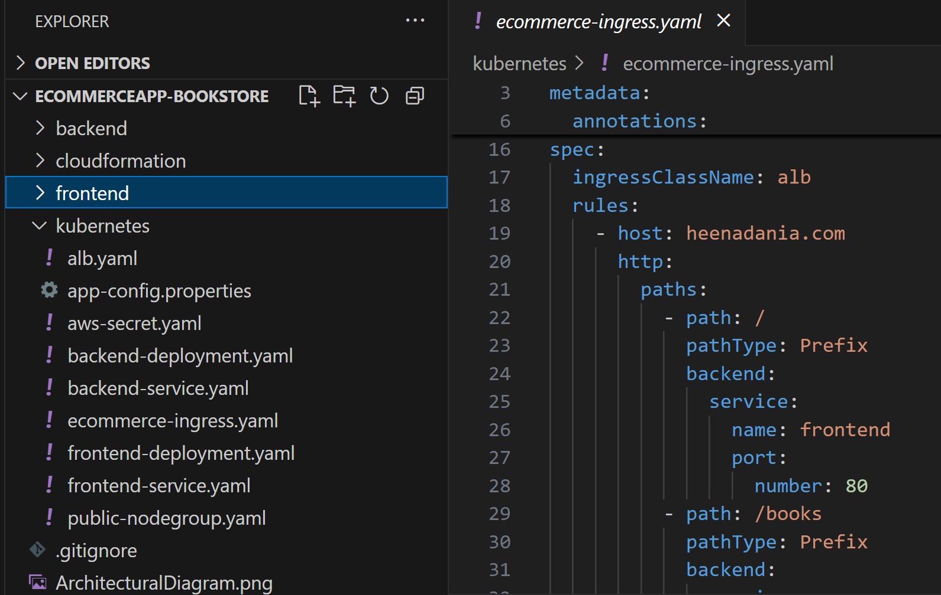



12. Kubernetes folder structure showing manifests files and ingress file for the ecommerce-app.

**4.6 Secret Management with AWS Secrets Manager**

* All sensitive data (DB credentials, API keys) stored in Secrets Manager, encrypted with KMS.
* Secrets are never hardcoded or exposed in code or images; rotation and audit logging are enabled for compliance.

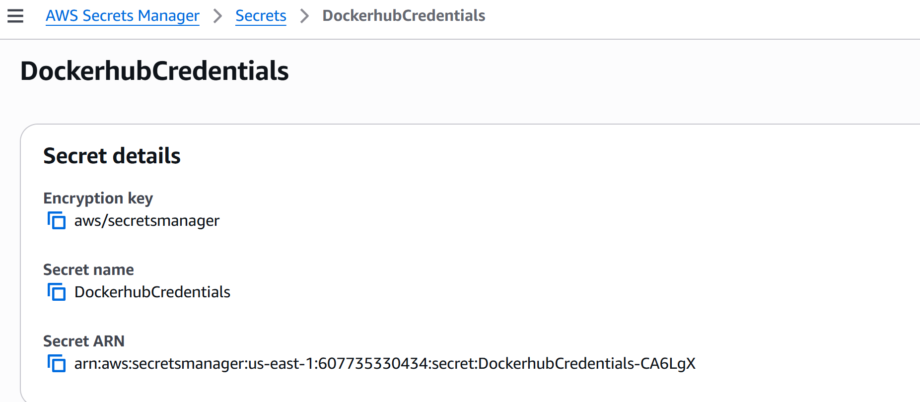

13. DockerHub, RDS, GitHub and many other secrets are safely stored and retrieved by Secrets Manager.

**4.7 Certificate Management with ACM**

* ACM provisions and manages SSL/TLS certificates for ALB endpoints; certificates are automatically renewed.
* All frontend and backend traffic is encrypted in transit using managed certificates.

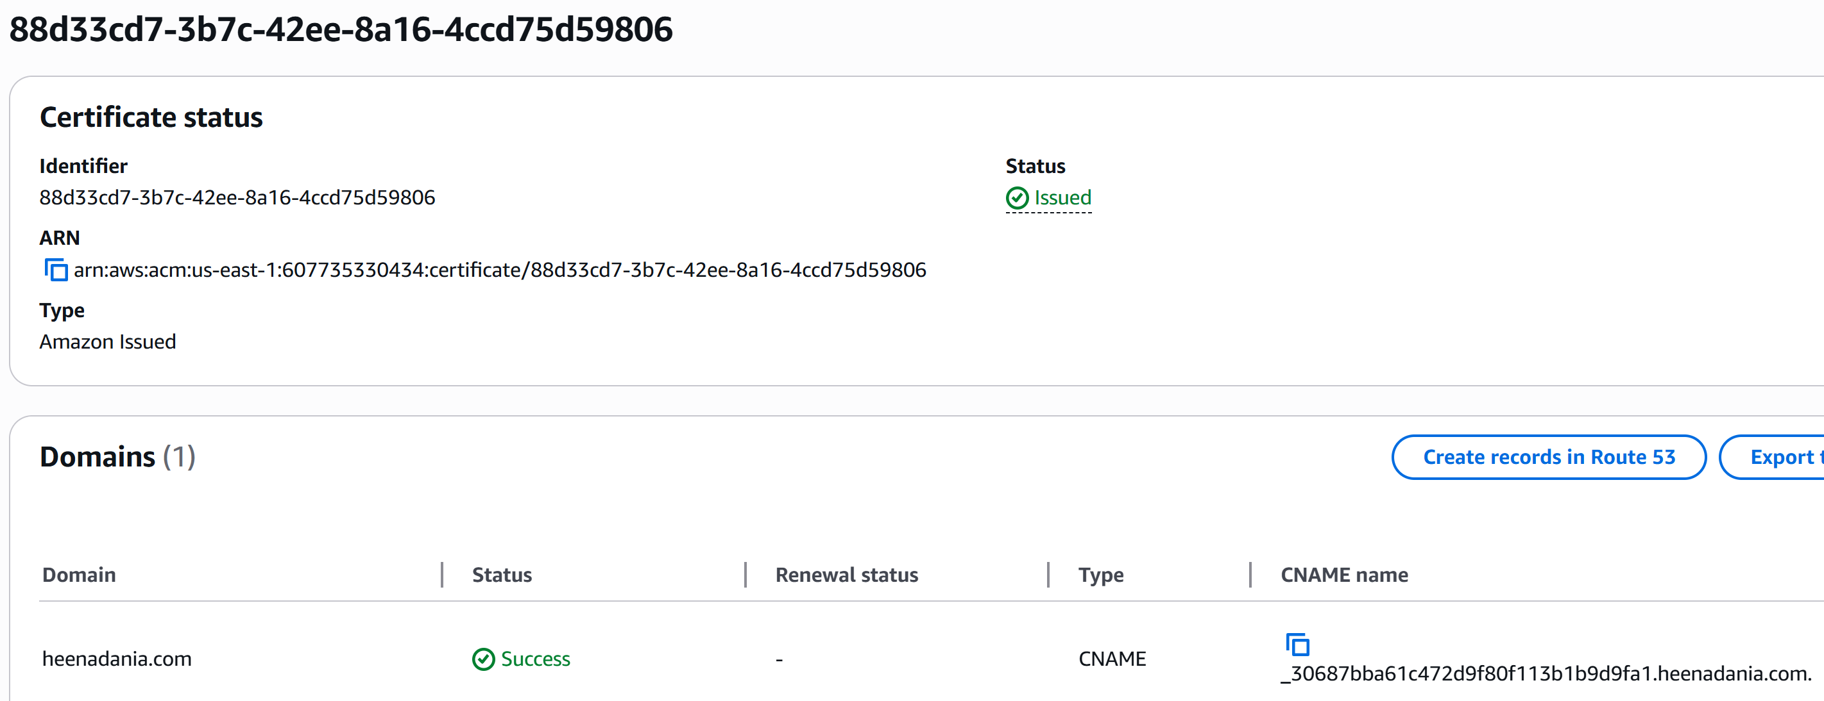

14. Security Certificate created and is being managed by AWS certificate Manager to secure the application running at domain “heenadania.com”.

**4.8 Content Delivery, Security, and DNS**

* Amazon CloudFront accelerates and globally distributes all web traffic.
* AWS WAF protects applications from common web threats and attacks.
* Amazon Route 53 manages custom domains and provides reliable DNS routing.
* WAF web ACLs are attached to CloudFront for automatic blocking of malicious requests and DDoS protection.

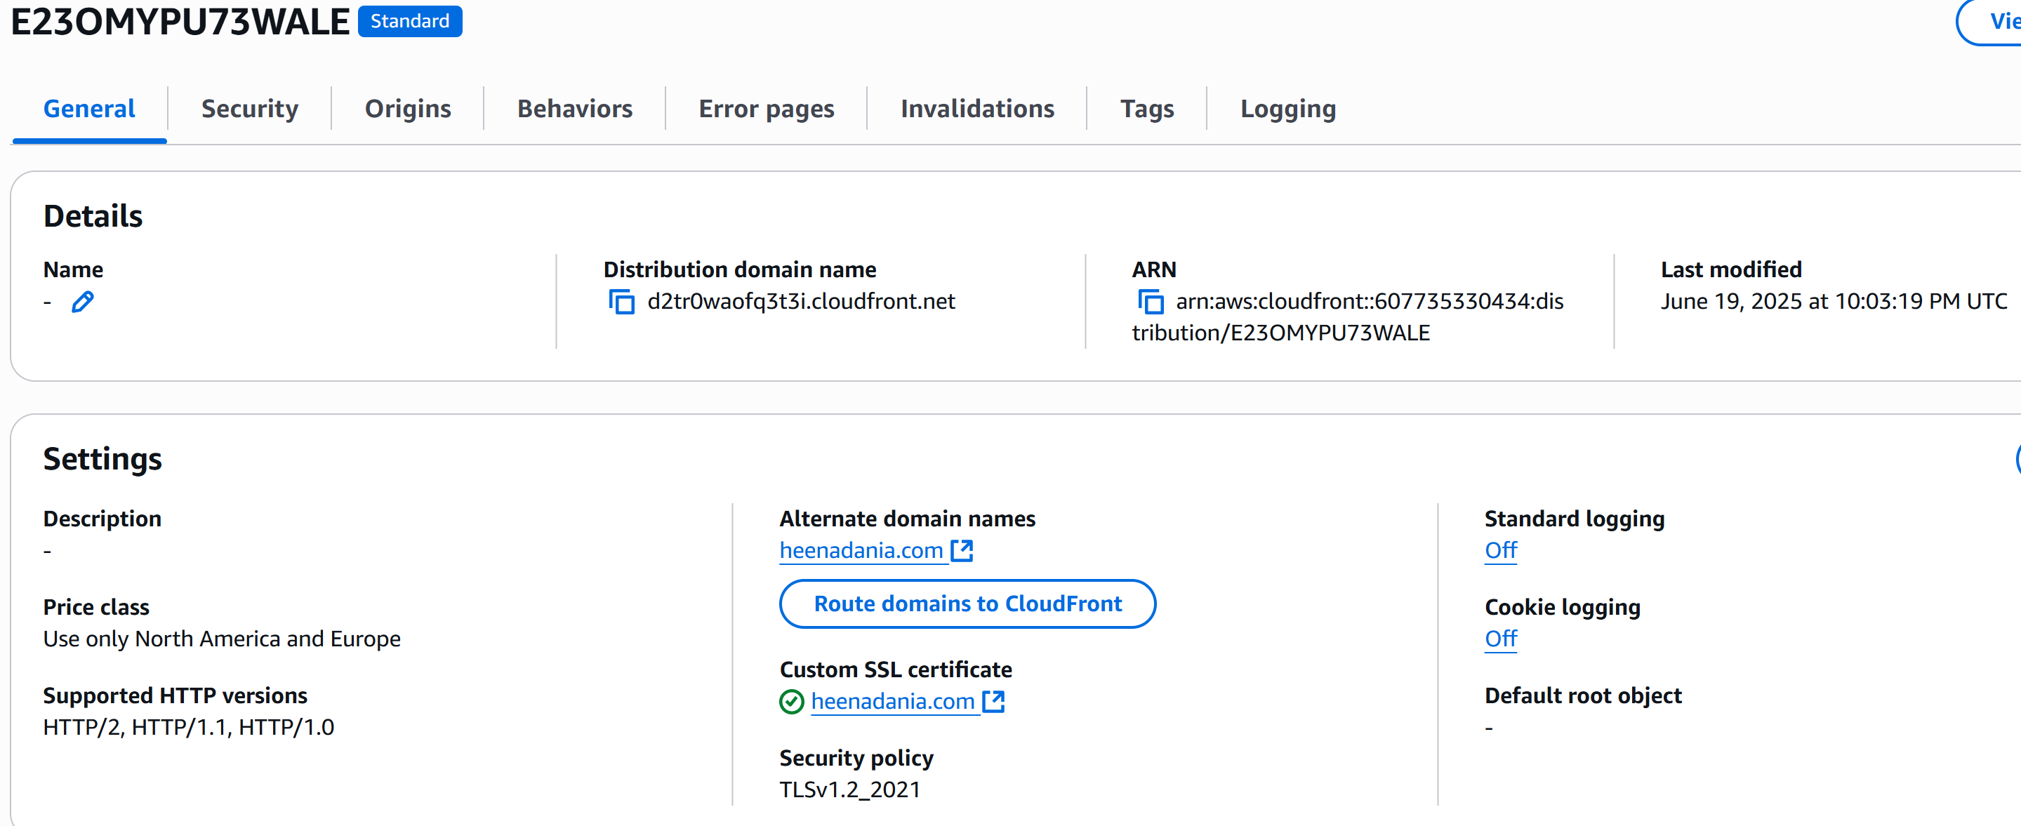

15. CloudFront Content Delivery Network securely delivers content with low latency and high transfer speeds via edge locations.

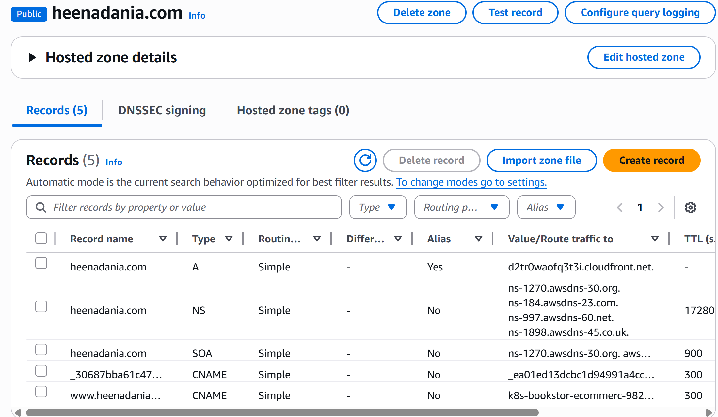

16. Route 53 - Hosted Zone for the domain “heenadania.com”.

**4.9 User Authentication with Cognito**

* Cognito manages secure user sign-up, sign-in, and access control.
* Supports multi-factor authentication (MFA) and social logins.

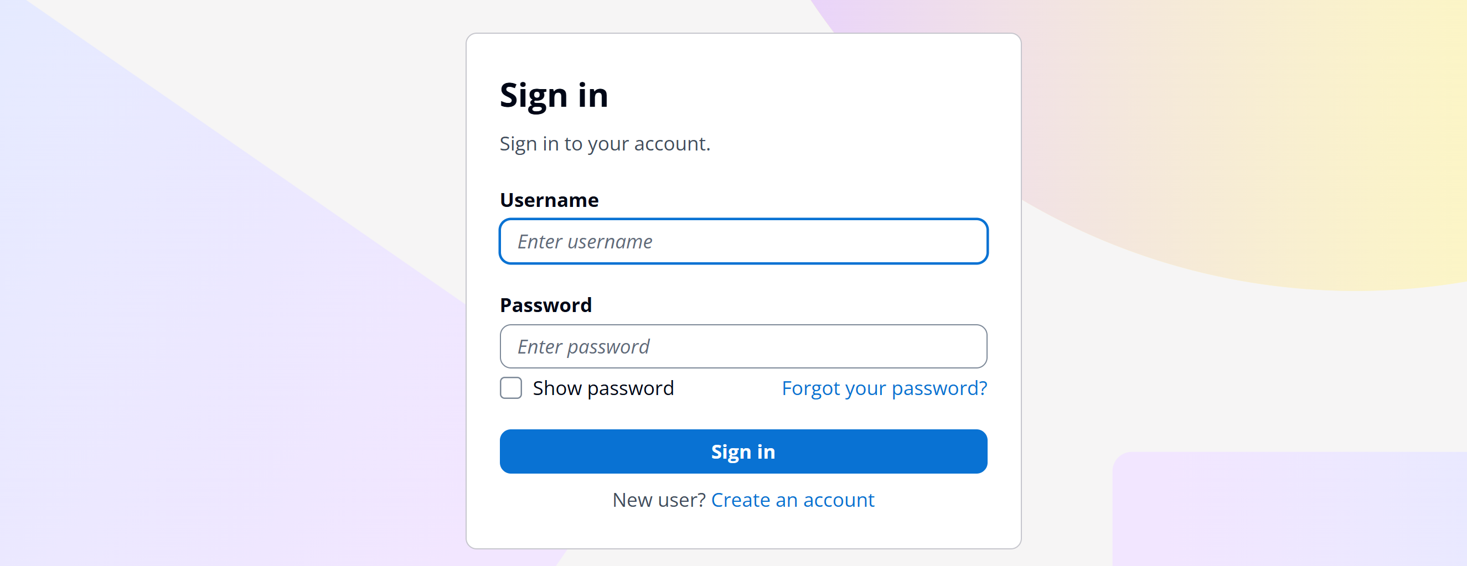

17. AWS Cognito login page displaying before accessing the ecommerce app for bookstore.

**4.10 Monitoring & Notifications**

* CloudWatch collects logs and metrics from EKS, ALB, and app containers enabling real-time monitoring and alerting.
* SNS topics send notifications for pipeline failures, scaling events, and operational alarms to ensure rapid response to issues.
* AWS CloudTrail tracks all account activity and saves detailed logs to S3 for auditing and compliance.

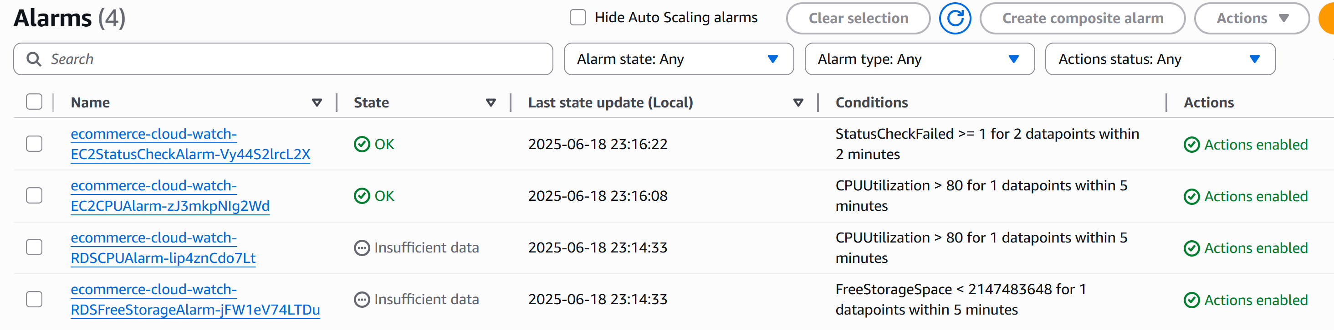

18. CloudWatch Alarms created to collects logs EKS, ALB and many other for real-time monitoring.

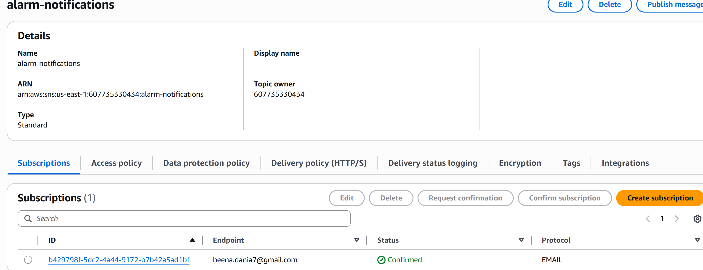

19. SNS topic created and subscribed for real-time alerting to admin.

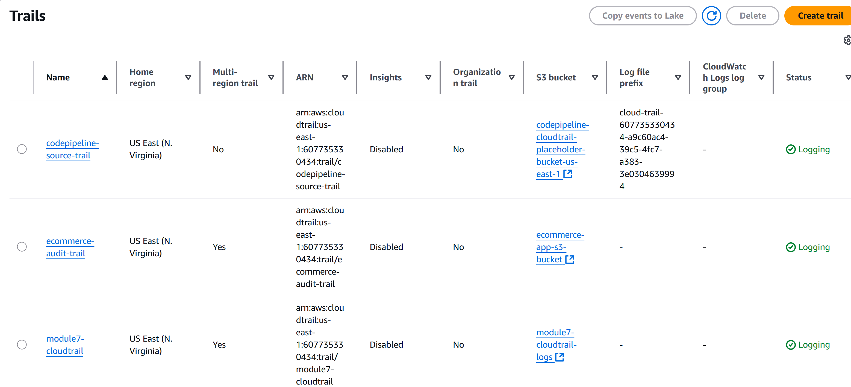

20. CloudTrail tracking all account activity and saving the logs S3 bucket.

**5. Testing & Validation**

**5.1 Build & Deployment Validation**

* Verified that all builds succeed in CodeBuild and containers are successfully pushed to ECR.
* Confirmed that Kubernetes manifests are correctly applied and pods are running in EKS.
* Checked that ALB endpoints are reachable and routing traffic to the correct pods.

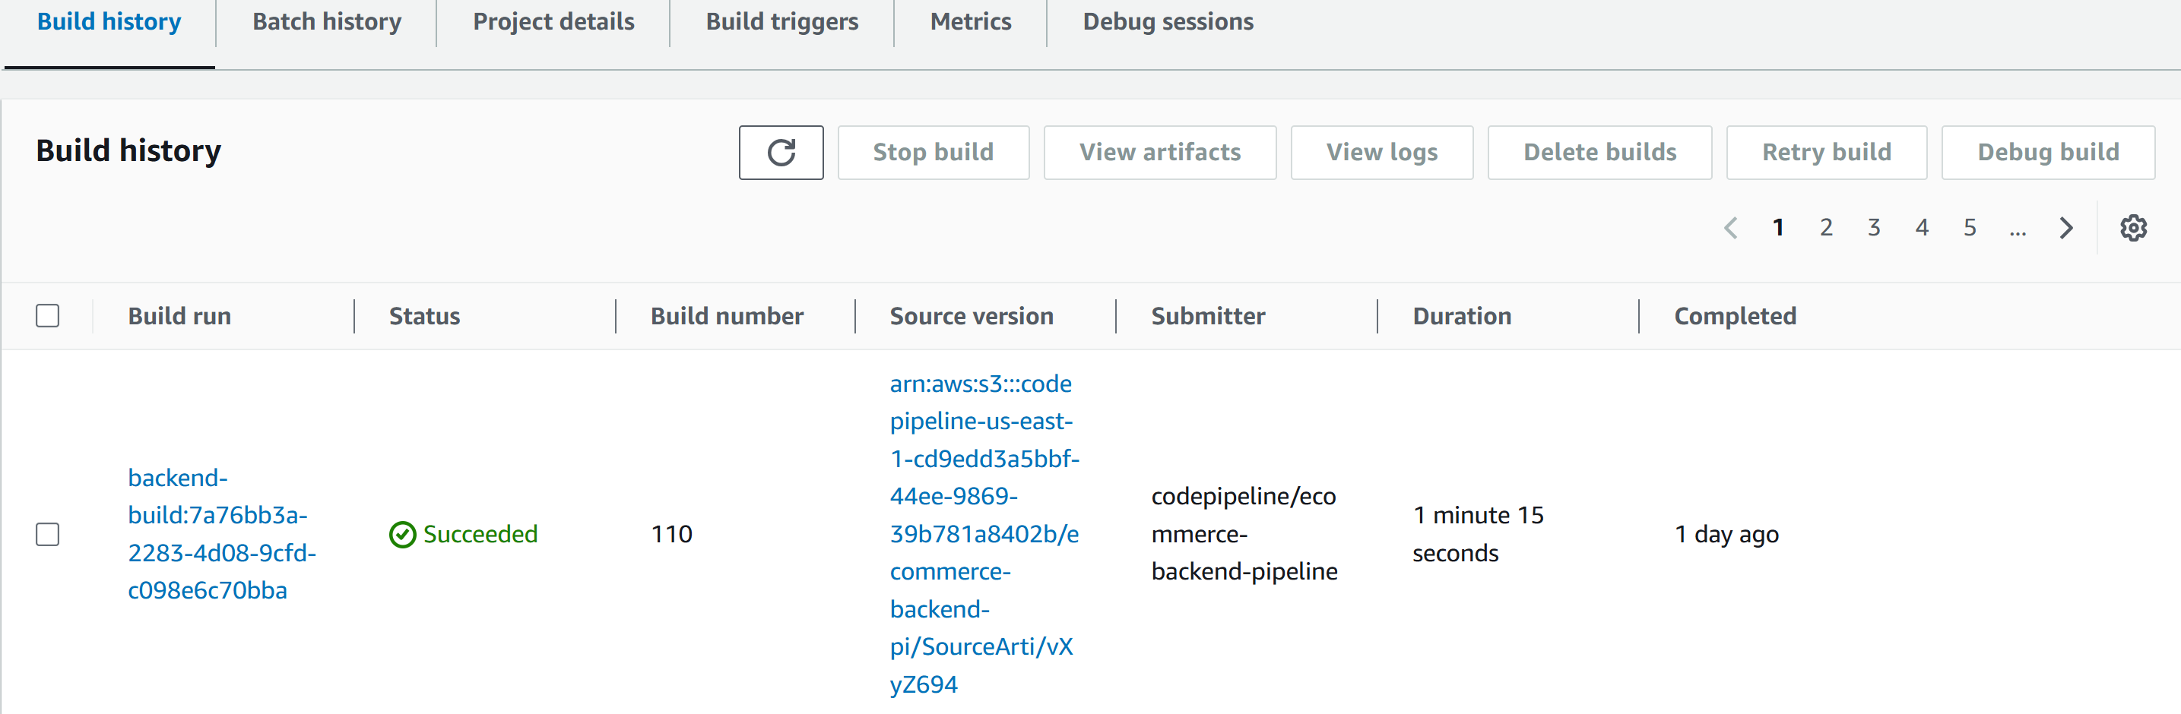

21. CodeBuild showing successful build for the latest commit to GitHub repository.

**5.2 Manual Application Testing**

* Accessed the deployed frontend application via the ALB endpoint to confirm the UI loads and navigation works.
* Performed manual user flows such as browsing products, adding to cart, and checking out.
* Used browser developer tools and network logs to verify API calls to the backend are functioning and returning expected data.
* Verified backend endpoints directly using tools like Postman or CURL to ensure API responses are as expected.
* Checked CloudWatch logs for errors or warnings during manual testing sessions.

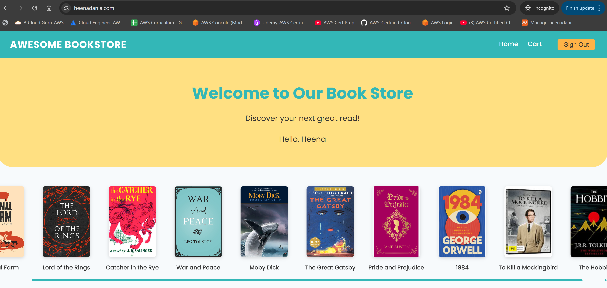

22. Successfully able to access the frontend of the ecommerce app at url <https://heenadania.com/> where all the books details are being fetched from RDS and images form S3.

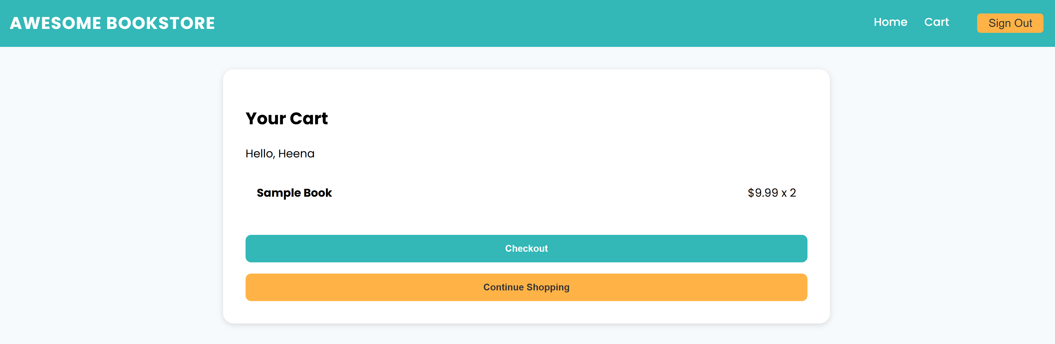

23. Cart Page of the bookstore app.

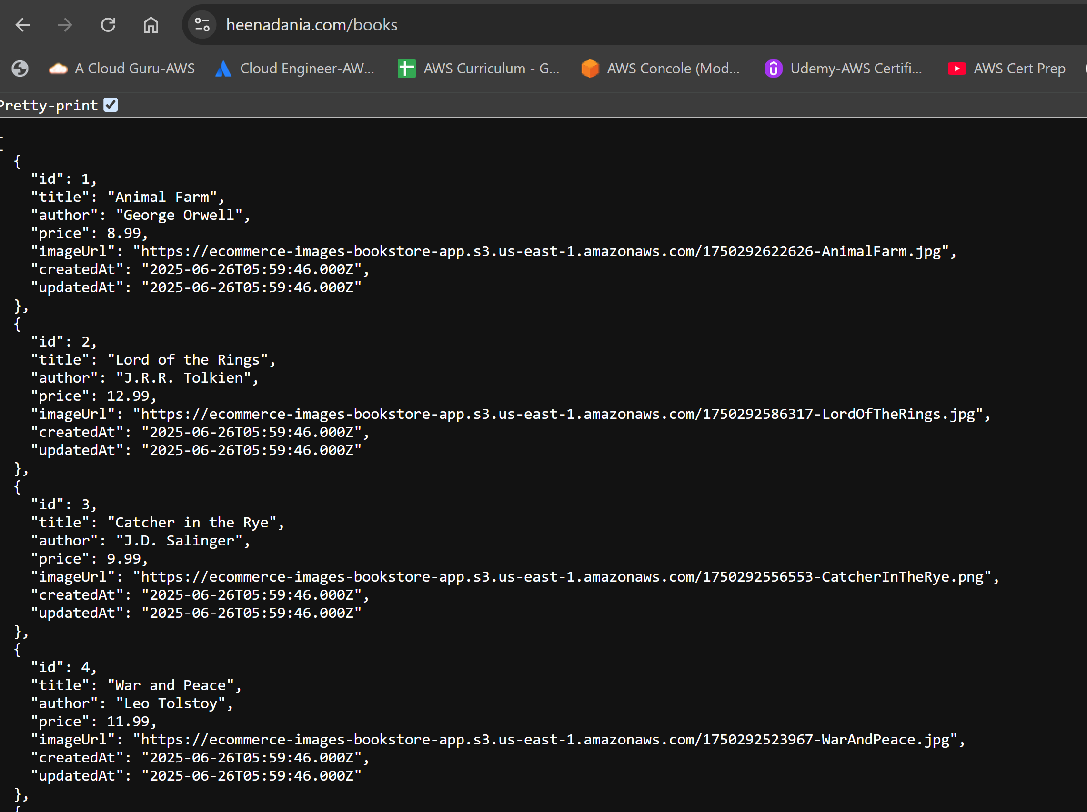

24. Successfully able to access the backend of the ecommerce app at url <https://heenadania.com/books> fetching all the details from RDS.

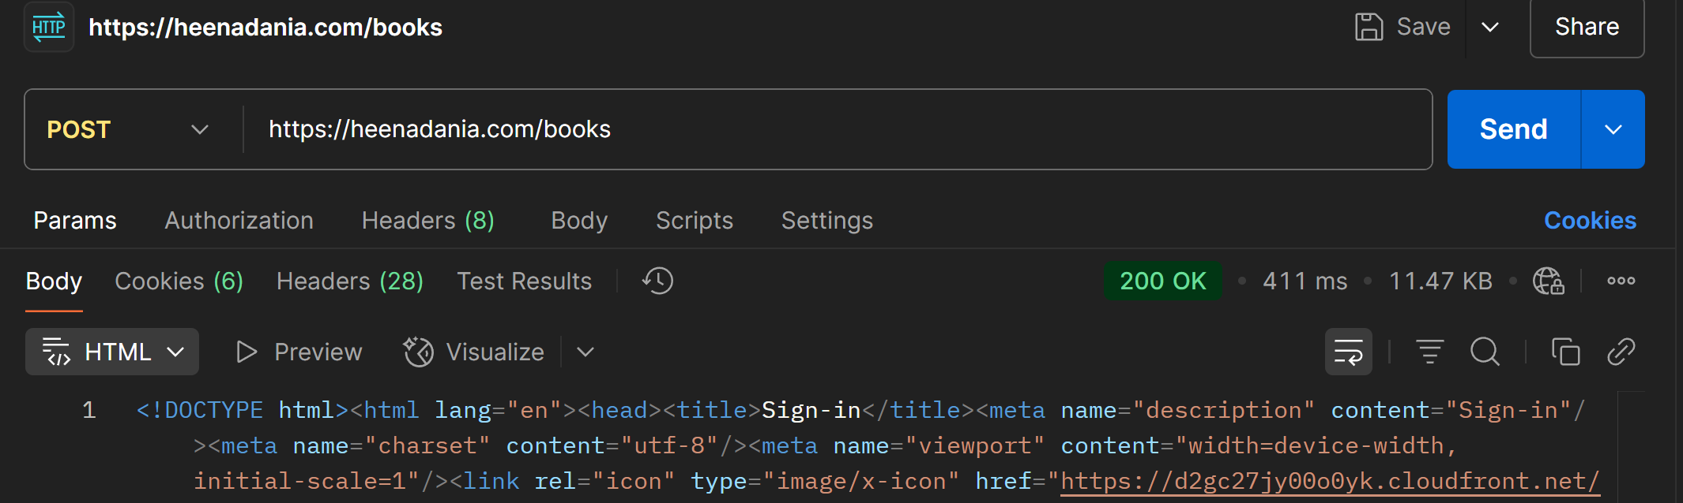

25. Postman showing “200 OK” API response.

**5.3 Monitoring & Alert Validation**

* Simulated build failures and deployment errors to ensure SNS notifications are triggered.
* Monitored CloudWatch for log entries and alarms during both normal operation and simulated error conditions.

**6. Challenges & Solutions**

| **S.NO.** | **CHALLENGE** | **SOLUTION** |
| --- | --- | --- |
| **1.** | **Cognito User Pool Integration:** Initially, I was unable to see the login pages or authenticate users because my frontend and backend were not correctly configured to interact with the AWS Cognito User Pool. | Carefully reviewed the Cognito configuration, updated the app’s environment variables, and ensured the correct user pool IDs and client IDs were referenced in both frontend and backend. Also double-checked callback URLs and CORS settings to allow proper authentication flows. |
| **2.** | **Application Load Balancer (ALB) Setup**: I faced issues with the ALB not routing traffic correctly to my EKS services, and sometimes the ALB was not even provisioning as expected. | Debugged the ALB and Kubernetes Ingress configuration, ensuring that the correct target groups, security groups, and health checks were set up. Also made sure the Kubernetes manifests referenced the correct service ports and annotations for AWS ALB integration. |
| **3.** | **Fetching Book Images from S3:** Book images were not loading in the frontend because S3 objects were private by default, causing access errors. | Updated the S3 bucket policy to make the required image objects public. Verified that only the necessary files were exposed and that the bucket policy did not compromise overall security. |
| **4.** | **CodeBuild Authentication:** Initially tried to push code and trigger builds using AWS root user credentials, but CodeBuild does not accept root user tokens for security reasons. | Created a dedicated IAM admin user, granted it the necessary permissions, and generated access keys for use with CodeBuild and other AWS CLI operations. This followed AWS best practices and improved security. |
| **5.** | **Session Token Confusion:** Configured AWS CLI using session tokens instead of aws configure, which led to confusion and errors when tokens expired or were deleted, as the CLI would retain old values. | Switched to using aws configure with long-lived access keys for the IAM admin user and avoided using session tokens for regular CLI operations. Cleaned up any old environment variables and configuration files to prevent further confusion. |

**7. Lessons Learned**

* Gained hands-on experience with EKS, Kubernetes manifests, and AWS networking.
* Improved troubleshooting skills for modern JavaScript (ESM, Babel, Node) in CI/CD.
* Learned the importance of robust, automated deployment validation and error handling in cloud-native pipelines.
* Enhanced skills in debugging, log analysis, and iterative problem solving in a real-world DevOps workflow.

**8. Future Scope**

* Migrate from EC2 to ECS or EKS with Fargate for serverless container management.
* Use AWS Lambda for running serverless backend functions and event-driven tasks.
* Implement ElastiCache (Redis) for efficient session management and caching.
* Integrate Prometheus and Grafana for advanced monitoring and observability.
* Improve security by refining IAM policies and adding AWS WAF for application protection.
* Adopt Blue/Green or Canary deployment strategies to minimize downtime during releases.
* Explore cost optimization through spot instances and resource right-sizing.

**9. Conclusion**

This project demonstrates how to build, deploy, and validate a modern, scalable e-commerce application using AWS DevOps services and Kubernetes. By automating every step—from code commit to production deployment—and validating deployments manually and through monitoring, we achieved a robust, secure, and observable platform ready for real-world use. The lessons learned and patterns established here are directly applicable to any cloud-native, microservices-based application.

**10. Demo**

**Application URL:**

* for Frontend- [*https://heenadania.com/*](https://heenadania.com/)
* for Backend-[*https://heenadania.com/books*](https://heenadania.com/books)

**11. Appendix**

* **GitHub Repository:**  
  <https://github.com/HeenaDania/ecommerce-eks-cicd.git>
* **CloudFormation Templates:** <https://github.com/HeenaDania/ecommerce-eks-cicd/tree/main/cloudformation>
* **CodePipeline Buildspecs:**
  + for Frontend- [*https://github.com/HeenaDania/ecommerce-eks-cicd/blob/main/frontend/buildspec.yml*](https://github.com/HeenaDania/ecommerce-eks-cicd/blob/main/frontend/buildspec.yml)
  + for Backend-[*https://github.com/HeenaDania/ecommerce-eks-cicd/blob/main/backend/buildspec.yml*](https://github.com/HeenaDania/ecommerce-eks-cicd/blob/main/backend/buildspec.yml)